**PHP**

**What is PHP**

* PHP stands for Hypertext Preprocessor.
* PHP is an interpreted language, i.e., there is no need for compilation.
* PHP is a server-side scripting language.
* PHP is faster than other scripting languages, for example, ASP and JSP.

**Web Development**

PHP is widely used in web development nowadays. PHP can develop dynamic websites easily. But you must have the basic the knowledge of following technologies for web development as well.

* HTML
* CSS
* JavaScript

**Characteristics of PHP**

Five important characteristics make PHP's practical nature possible −

* Simplicity
* Efficiency
* Security
* Flexibility
* Familiarity

**PHP Features**

**There are given many features of PHP.**

* **Performance**: Script written in PHP executes much faster then those scripts written in other languages such as JSP & ASP.
* **Open Source Software**: PHP source code is free available on the web, you can developed all the version of PHP according to your requirement without paying any cost.
* **Platform Independent**: PHP are available for WINDOWS, MAC, LINUX & UNIX operating system. A PHP application developed in one OS can be easily executed in other OS also.
* **Compatibility**: PHP is compatible with almost all local servers used today like Apache, IIS etc.
* **Embedded**: PHP code can be easily embedded within HTML tags and script.

**Install PHP**

To install PHP, we will suggest you to install AMP (Apache, MySQL, PHP) software stack. It is available for all operating systems. There are many AMP options available in the market that are given below:

* **WAMP** for Windows
* **LAMP** for Linux
* **MAMP** for Mac
* **SAMP** for Solaris
* **FAMP** for FreeBSD
* **XAMPP** (Cross, Apache, MySQL, PHP, Perl) for Cross Platform: It includes some other components too such as FileZilla, OpenSSL, Webalizer, Mercury Mail etc.

**PHP Example**

It is very easy to create a simple PHP example. To do so, create a file and write HTML tags + PHP code and save this file with .php extension.

All PHP code goes between php tag. A syntax of PHP tag is given below:

**<?php**

//your code here

**?>**

Example:

**<html>**

**<body>**

**<?php**

echo "**<h2>**Hello First PHP**</h2>**";

**?>**

**</body>**

**</html>**

## PHP echo: printing string

**<?php**

echo "Hello by PHP echo";

**?>**

**Run a PHP program in XAMPP Server**

PHP program can be run under various like WAMP, XAMPP etc.

* **WAMP Server**: this server is a web development platform which helps in creating dynamic web applications.
* **XAMPP Server**: It is a free open source cross-platfrom web server package.

I am using XamppServer to run my program, you can download it .  
After downloading, just follow the following step to start xampp server:

## Step1

Install XAMPP

## Step2

Assume you installed xampp in C Drive.  
Go to: **C:\xampp\htdocs**

Create your own folder, name it for example as **tutorialspoint**.

## Step3

Now create your first php program in xampp and name it as**“add.php”**:

## Step4

## <html>

## <head><title>Addition php</title></head>

## <body>

## <?php

## print "<h2>php program to add two numbers...</h2><br />";

## $val1 = 20;

## $val2 = 20;

## $sum = $val2 + $val2; /* Assignment operator */

## echo "Result(SUM): $sum";

## ?>

## </body>

## </html>

Now double click on “**XAAMP CONTROL PANEL**” on desktop and START “**Apache**”  
(icon also appears on the bottom)

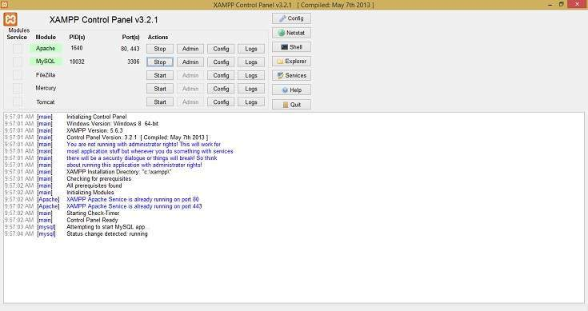

## Step5

Type **localhost** on your browser and press enter:  
It will show the following:

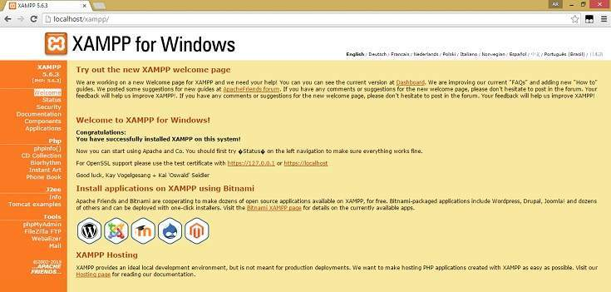

## Step6

Now type the following on browser:  
**http://localhost/**

## Step7

Click on “**add.php**” and it will show the following:

The RESULT is 40 by adding both the values.  
This way you can run your php program in XAMPP server…